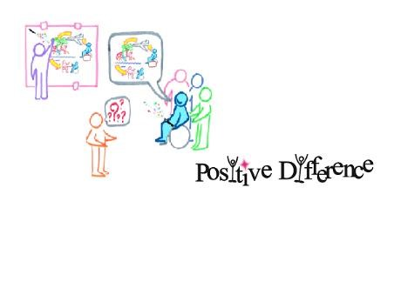
AIM
Autism Inclusion Matters

What is AIM?
AIM is a group on the Isle of Wight for adults (over 18) who have ‘high functioning’ Autism or Aspergers, also known as an Autistic Spectrum Disorder (ASD) or Autistic Spectrum Condition (ASC). It is not a group for parents or carers, or professionals.
AIM is a user led group. This means that, with support, people who have ASD will decide what happens in the group and also help to run the groups.

How can I be involved?
We run 2 social groups aimed at helping people who have ASD who may feel lonely, or find it difficult to meet people and make friends. One group goes out in the community doing activities that are chosen by members. This group meets in the evening on the last Thursday of every month.
The other group at a community hall, and also includes a support group. This is once a month on a Monday.

AIM social groups are free to attend. You only pay for the cost of the activity. We do not provide any support workers or carers, however there are volunteer supporters and a group advocate to assist with social difficulties and anxiety.

AIM is also an advocacy group, to listen to what adults with ASD have to say about life on the Isle of Wight.
We are creating new ways of doing this to involve more people, to listen to more people and to make sure that services and businesses listen to what you have to say and act on it. Some members become involved in training, or attending meetings.

If you would like to be involved, or want to have more information about any of our groups or activities please complete the contact form. You will be sent details each month of our activities.

Our activities are advertised each month
at @positivedifferenceiow

Or at www.positivedifferenceiow.co.uk/aim

AIM

Autism Inclusion Matters
Please fill in this form to help us make the AIM group a good place for people to meet. The information will be kept safe and private and only used for the group, to share information about the group and to share other information about ASD on the Isle of Wight that you might find useful.
Contacting You
Name
Date of birth
What do you like to be called?
What is your address? |  | Number and Street  Town  Postcode  Telephone number home  mobile
What is your email Address?
To reduce our costs, we cannot post information to everyone. We must have a mobile phone number or email address to send information to you.
If you DO NOT have access to email or a mobile phone to receive a text message please tick this box
If there is someone else you would like us to give information to or contact instead of you please tell us how to contact them here:
What format would you like any letters or meeting notes |  | Easy read |  | Full |  |  | Other
Please give us some more information to help us plan our groups. We cannot meet everyone’s needs but will try to make sure that some activities are at times and places that suit all members.
When are you able to meet? | Day time |  | evening |  |  | Weekend only
Are you able to travel to activities? | Yes |  | Yes but I will need help planning my route |  |  | No I cannot travel independently and have no one to help me
If you have a car, might you give another member a lift? | Yes |  | No |  |  | Not sure
Do you have any cultural or religious needs that we need to be aware of?
Do you have any strong fears or phobias that we need to be aware of?
Do you have any other disability or access needs that we need to be aware of?
I understand that this information will be used to plan the activities for the AIM group and to send me information related to this. If I no longer wish to receive this information I can let AIM know at any time. My information will be kept securely in accordance with the data protection act and will not be shared with anyone without my consent.
I understand that any social activities organised may have a cost which I will need to pay. This will be
made clear to me.
I understand that when I take part in any social groups or activities I do so at my own risk, having thought about my health and whether they are suitable for me. The AIM Partnership will not be providing any support workers, medical or physical support, or personal care
Signature |  |  |  |  | Date

Please tick any subjects that are of interest to you. We will not be organising all of these, but will look at the interests of all of the group members to help plan activities and match people who have shared interests. Please feel free to add any ideas or other interests to the list. We would love to hear more ideas!
Art | Pub quiz | Stamps | Meal out | Local history | Computer games
Dr Who | Water sports | Classic cars | Photography | Bike riding | Buses
Bowling | Surfing | Trains | Pub or café | Theatre | Crafting
Beach activities | Baking / cookery | Knitting or sewing | Sports | Walking | Dinosaurs/ fossils
Gardening or horticulture | Cinema | Geology | Comics / animation | Bingo

Please return this form to the AIM Administrator

By Post: AIM at People Matter, 1-2 Bernard Way, Newport, PO30 5YL
By Email: aimisleofwight@gmail.com
For any queries contact us at AIM on: 07444737097and ask to speak to the AIM coordinator.

